**Project 2:**

**Instagram User Analytics**

**SQL Tasks:**

**---------------------------------------------------------------------------**

1. **Marketing Analysis:**
2. Loyal User Award- Identity the five oldest users on Instagram from the provided database.

Ans- **select * from users order by created_at asc limit 5;**

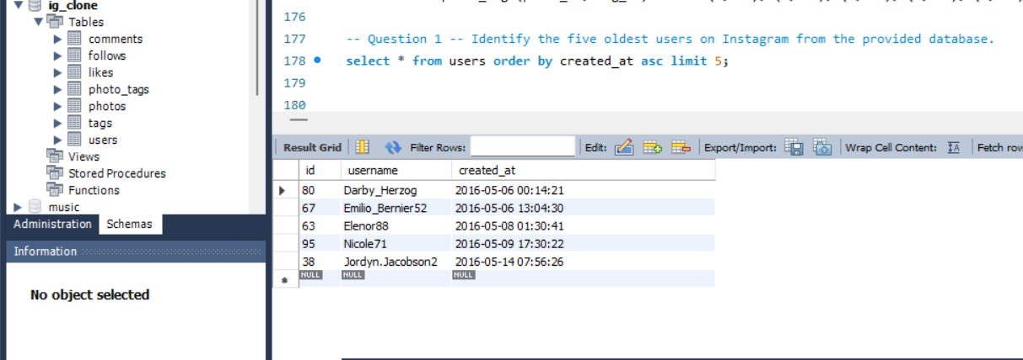

1. Inactive User Engagement- Identify users who have never posted a single photo on Instagram.

Ans- **select user.id, user.username, user.created_at from users user**

**left join photos photo**

**on user.id = photo.user_id**

**where photo.id is null**

**order by user.id asc;**

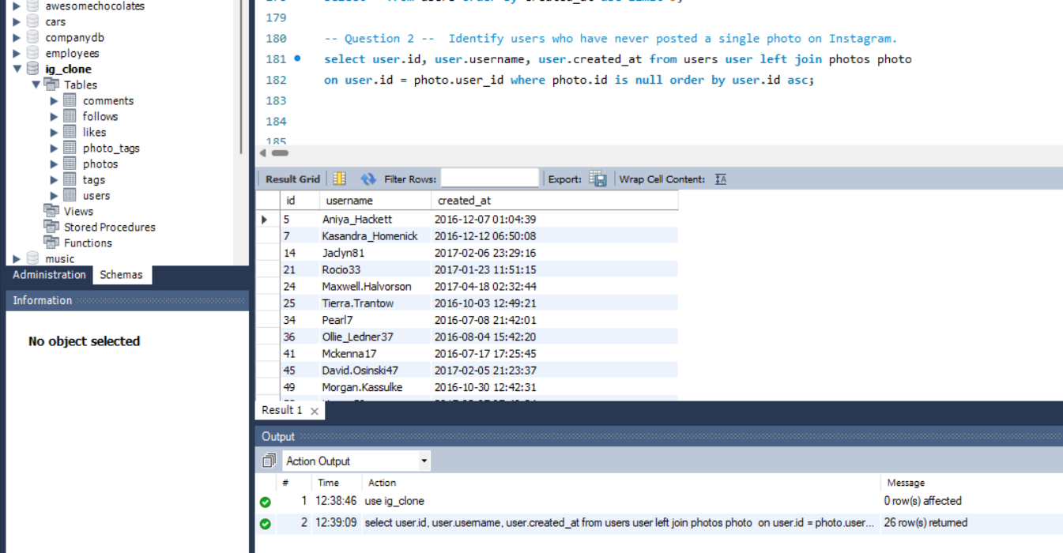

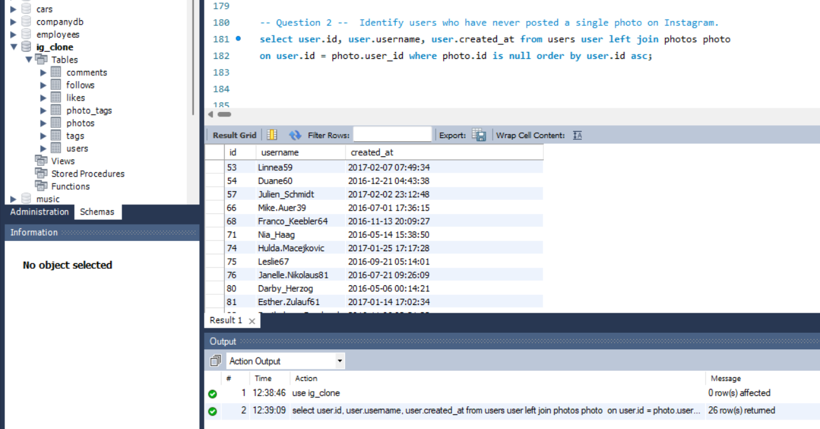

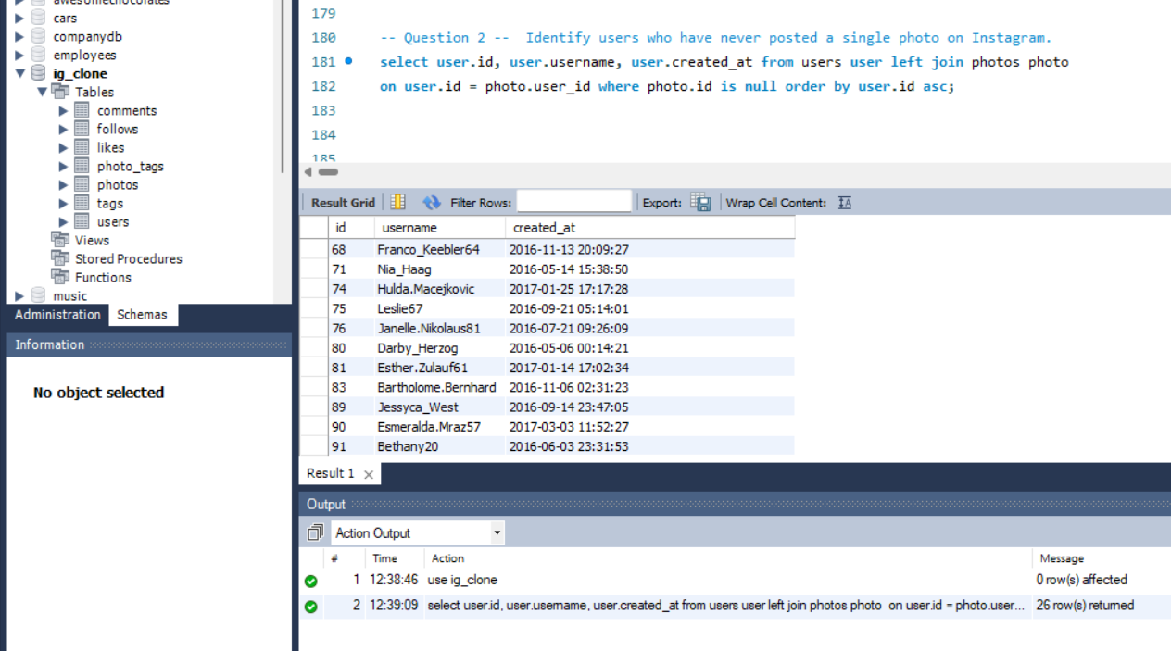

1. Contest Winner Declaration- Determine the winner of the contest and provide their details to the team.

Ans- **select count(photo_id) as counts, user.id, user.username, user.created_at from likes**

**likes join photos photo**

**on likes.photo_id = photo.id join**

**users user**

**on user.id = photo.user_id**

**group by photo_id**

**order by counts desc limit 1;**

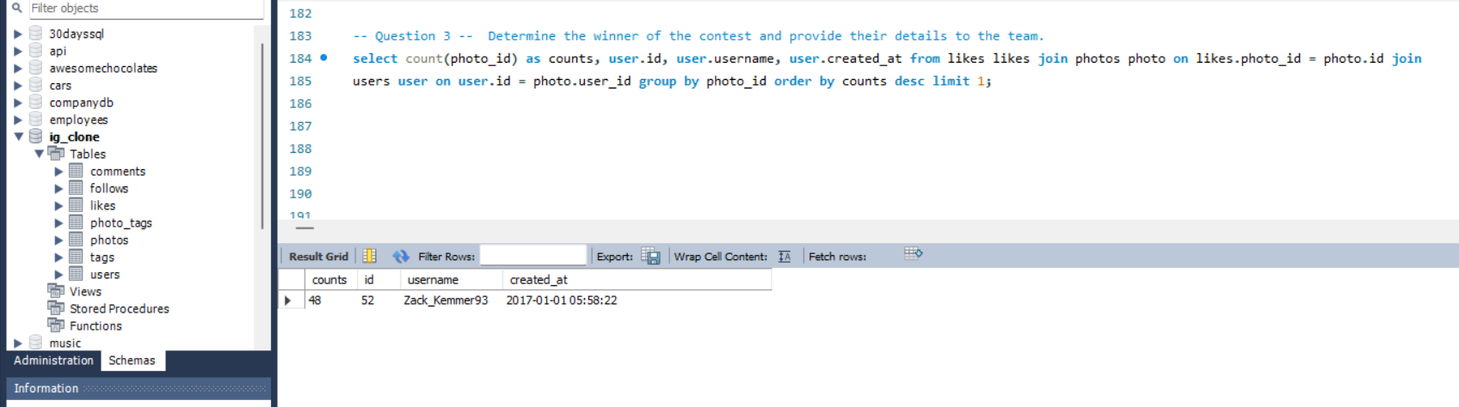

1. Hashtag Research- Identify and suggest the top five most commonly used hashtags on the platform.

Ans- **select tag.id, tag.tag_name, count(tag_id) as countOfMostUsedTags from photo_tags photoTag**

**join tags tag**

**on photoTag.tag_id = tag.id**

**group by tag_id**

**order by countOfMostUsedTags desc limit 5;**

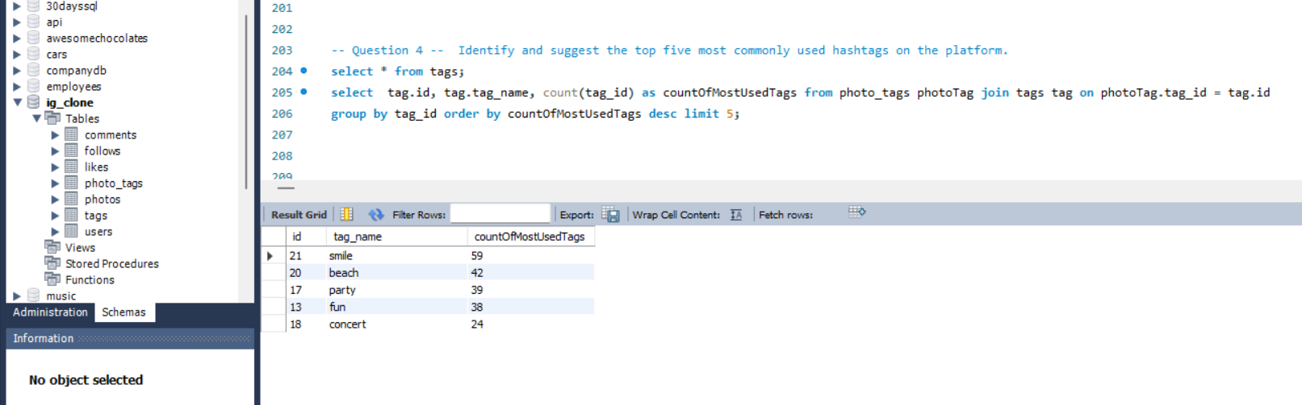

1. Ad Campaign Launch- Determine the day of the week when most users register on Instagram. Provide insights on when to schedule an ad campaign.

Ans- **with cte as (**

**select id, username, created_at, weekday(created_at) as weekday from users order by created_at asc)**

**select weekday, count(weekday) as maxregister from cte group by weekday order by maxregister desc;**

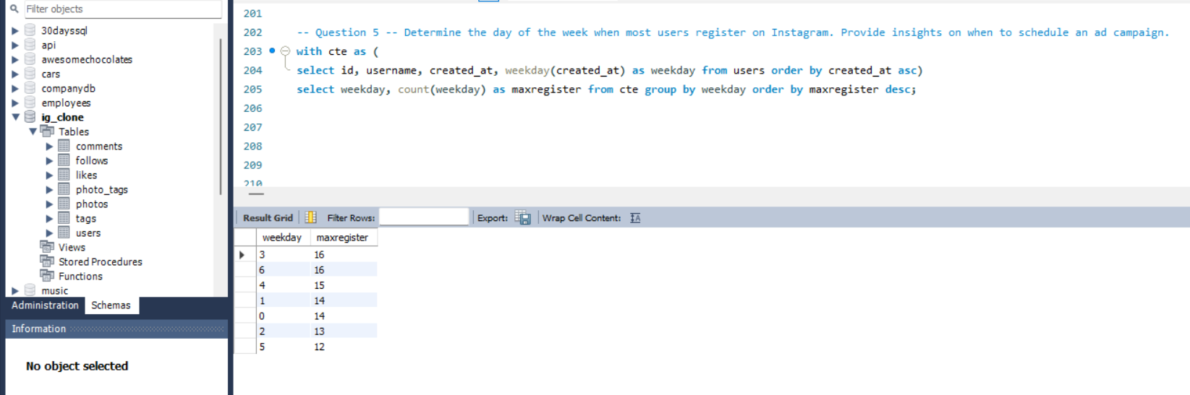

It's the Mid-day of the week and on the weekend when most users register on Instagram. If we campaign an ad on these days there is a high chance users can see the ad and share with friends and family as well and users will get to know about the Ad. They don’t need to spend extra time to see the ad if we schedule an ad campaign on these days.

1. **Investor Metrics:**
2. User Engagement- Calculate the average number of posts per user on Instagram. Also, provide the total number of photos on Instagram divided by the total number of users.

Ans- **with cte as (**

**select user_id, count(image_url) as countofposts from photos group by user_id)**

**select avg(countofposts) from cte;**

**-- Or**

**select avg(countofposts) from (**

**select user_id, count(*) as countofposts from photos group by user_id) as postCounts;**

**select count(image_url)/ count(distinct user_id) from photos;**

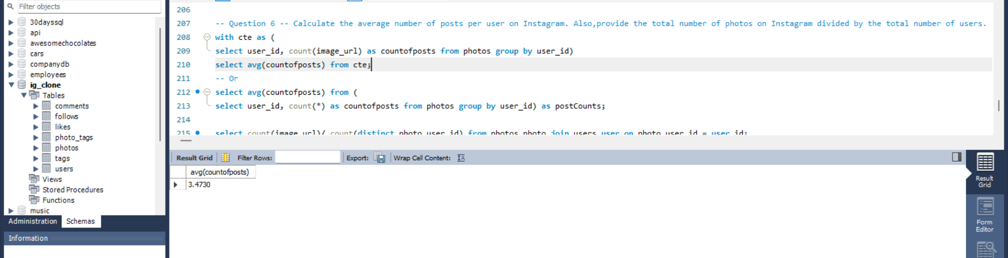

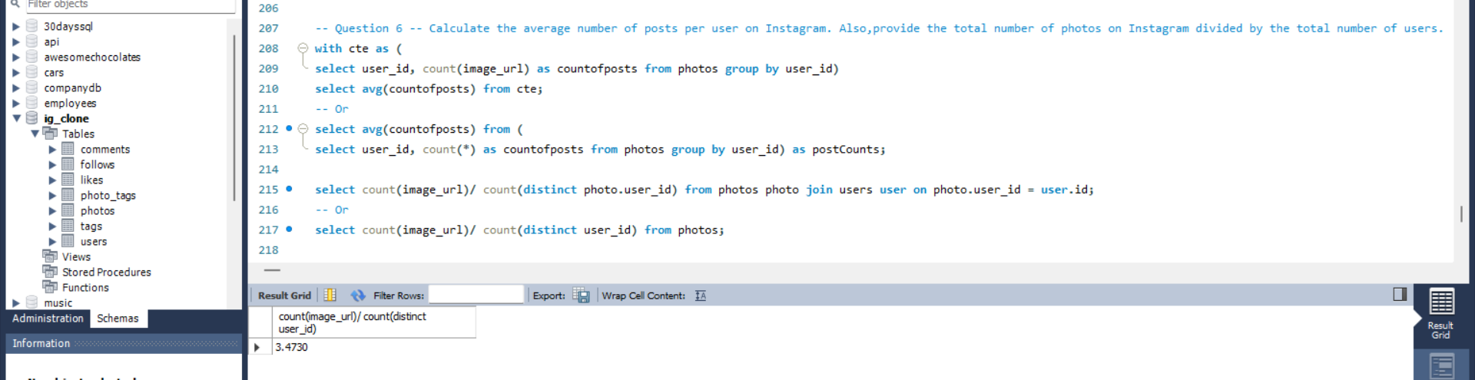

1. Bots & Fake Accounts- Identify users (potential bots) who have liked every single photo on the site, as this is not typically possible for a normal user.

Ans- **with cte as (**

**select *,**

**count(user_id) over(partition by user_id order by user_id asc) as 'count_index' from likes)**

**select distinct user_id, user.username, user.id, user.created_at from cte c1 join users user on c1.user_id = user.id where count_index =**

**(select count(distinct photo_id) from likes);**

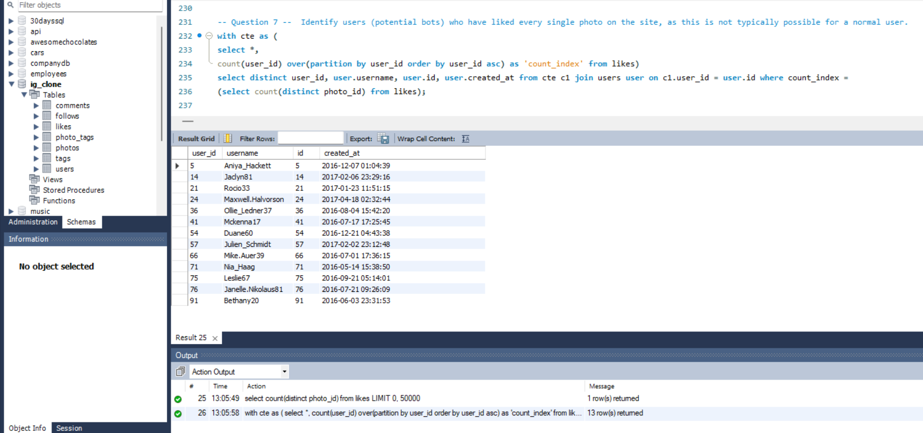

**Project Description**-

* The goal of this project is to have better interactions with the users. We can understand the mindset of the user with the help of this project. We track how users are interacting with the app and how often they visit the app.
* The purpose of this project is to find out the users who are using this app for the longest time so that we can reward our valuable users and also, we track like who is posting the pictures, who is active and who is inactive on this app and who likes the pictures most so that most liked profile will get rewarded.
* Insights- What I found out is there are many people who are using this app for the longest time. And there are many users who are having fake accounts as well and this is not the right thing for the user and business as well. They can misuse it. Most of the users are active on mid-day of the week and on weekends.

**Approach**-

* I took the simple approach to find out the answers so that I can make the people who are sitting at a higher level understand so that they can easily make any decisions which helps the business grow. I used simple select statements, joins and common table expressions, and aggregated functions as well.

**Tech-Stack Used**-

* I am using MySQL80 Workbench. It's user-friendly. User interface is quite simple and I believe for beginners it's easy to use. They won’t find any difficulty to understand the UI and we can start our learning.

**Insights**-

* While working on this project I gained a lot of knowledge. I came to know what real time projects are and how to do this kind of project with a simple approach. We must check all the scenarios to make any decisions for the growth of the business. With the help of all the answers we can easily make better decisions which can help our business.
* There are many users who have not posted any single photo. Probably, the reason is they are new to this app and I guess they are shy to post anything or maybe they are feeling insecure to post any photo.
* I believe for this kind of users we need to motivate them by using ads. We need to encourage them by posting photos and liking others' photos is not a crime.
* We get to know about many educational posts, and a few valuable information which is beneficial for many people which helps to know about the course (any kind of course) other than learning as well.
* We can interact with the user who is regularly active and posting good things on this app.

So, this type of ads and campaign we can provide to motivate them which really helps for the users and business.

**Result**-

* The team will get to know what areas we need improvements. Now the marketing team got to know on which day they campaign an ad so that most of the users can participate.
* The team gets to know about the popular hashtags used by most of the users.
* The team got to know about our longest user so we can give them a reward and also the most liked profile.